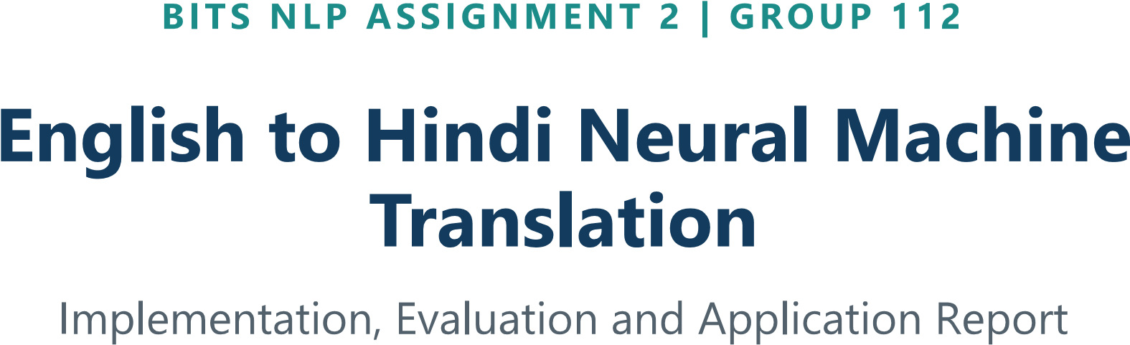

Abstract
This project implements an English-to-Hindi neural machine translation system for digital-content localization and educational accessibility. The solution uses a sequence-to-sequence architecture with a bidirectional LSTM encoder, Bahdanau additive attention and an LSTM decoder. A Streamlit interface supports single-sentence translation, greedy or beam-search decoding, and batch translation from TXT or CSV input.

The system was trained on a cleaned subset of the AI4Bharat Samanantar English-Hindi parallel corpus. After normalization, length filtering and deduplication, 44,917 sentence pairs were retained and divided into training, validation and test partitions. On a 500-pair evaluation sample, the checkpoint achieved BLEU 14.60, chrF 23.03, ROUGE-L 40.44 and METEOR 20.51.

Scope note. The checkpoint demonstrates a complete working pipeline and application, but translation quality is limited by the dataset size, vocabulary cutoff and frequent unknown tokens. Hindi examples in this report use valid Unicode text; square-box or otherwise invalid display artifacts are omitted.

Group Contribution
Student registration number | Name | Percentage of contribution
2025aa05883 | KAREKE BUVIKA | 100%
2025aa05337 | BOLLIBATHULA SAHANI | 100%
2025aa05567 | SONAM | 100%
2025aa05830 | SARDESAI SHRISHTI SANJAY | 100%
2025aa05906 | ANSHUL SAHU | 100%

1. Introduction and Objectives
English-authored documentation, government notices, educational material and digital content can be difficult to access for users who prefer Hindi. The project addresses this problem with a one-way EN-to-HI translation tool that exposes the trained model through a simple browser interface.

Objectives
Objective | Implementation outcome
Build an NMT model for English to Hindi. | Encoder-decoder PyTorch model with bidirectional encoding and additive attention.
Prepare reproducible training data. | Cleaning, filtering, splitting, vocabulary construction and fixed-length ID encoding.
Provide an accessible interface. | Streamlit app with single-sentence and batch upload workflows.
Measure translation quality. | BLEU, chrF, ROUGE-L, METEOR and targeted failure analysis.

Functional scope
The application accepts an English sentence directly or reads one sentence per line from a TXT file. It can also read a CSV file with an English column. Results are displayed alongside the source text and can be downloaded as a CSV file. Decoding can be switched between greedy search and beam search with a configurable beam width from 2 to 10.

2. Dataset and Preprocessing

Dataset
Property | Value
Source | AI4Bharat Samanantar corpus
Raw pull | Approximately 60,000 parallel English-Hindi pairs
License | CC BY-NC 4.0, non-commercial use
Cleaned pairs | 44,917
Split | 35,933 train / 4,492 validation / 4,492 test
Sentence length | 5 to 30 tokens per language before special tokens
Vocabulary cutoff | min_freq=4, built only from training data

Preprocessing sequence
The pipeline in src/preprocess.py and run_pipeline.py applies NFC Unicode normalization, URL and HTML-entity removal, zero-width formatting-character removal from Hindi, whitespace collapsing, English-only lowercasing, length filtering and pair deduplication. Each sequence is wrapped with <sos> and <eos>, encoded with the training vocabulary and right-padded to a fixed length of 34 tokens.

Data flow
Raw corpus → cleaned sentence pairs → 80/10/10 split → training-only vocabularies → integer ID matrices → PyTorch DataLoaders → trained checkpoint → CLI and Streamlit inference.

3. Improved Project Structure
The repository is organized around the lifecycle of the system: data preparation, model training, evaluation, inference and user-facing application. The following expanded view clarifies the responsibility of every major file and separates source data, generated artifacts and execution entry points.
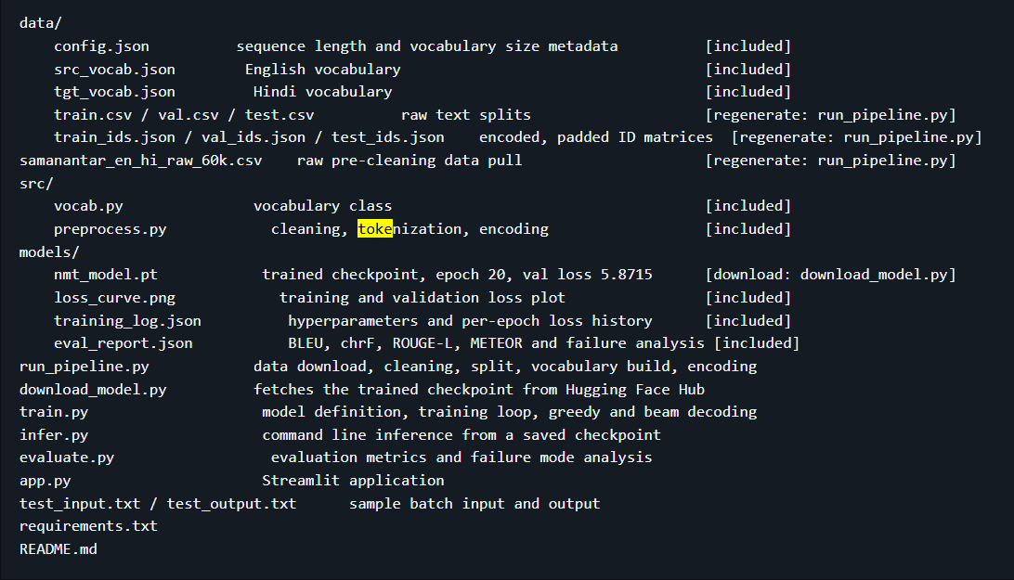

Execution responsibilities
Stage | Entry point | Primary outputs
Data preparation | python run_pipeline.py --min_freq 4 | Clean splits, vocabularies and encoded IDs in data/
Training | python train.py | Checkpoint, loss history and curve in media/
Evaluation | python evaluate.py --n_samples 500 | Metrics and failure analysis in media/eval_report.json
Inference | python infer.py | Terminal translation or CSV output
Application | streamlit run app.py | Browser-based translation interface at localhost:8501

4. Model and Implementation Details

Encoder
The encoder embeds source tokens using a 128-dimensional embedding table and processes them with a single-layer bidirectional LSTM of hidden size 256. The final forward and backward hidden and cell states are concatenated and projected through tanh-activated linear layers to initialize the single-direction decoder.

Attention and decoder
At each decoding step, Bahdanau additive attention scores every encoder output against the current decoder hidden state. The resulting context vector is concatenated with the current target embedding and passed to an LSTM. The decoder output, attention context and embedding are combined by a linear projection into the Hindi vocabulary distribution.

Training configuration
Setting | Value
Batch size | 128
Learning rate | 0.0005, (resumed run, reduced from an initial 1e-3)
Loss | Token cross-entropy with label smoothing 0.1; padding ignored
Regularization | Weight decay 1e-4 and gradient clipping at 1.0
Early stopping Patience | 6;
Best validation loss | 5.8715 at epoch 20

Decoding safeguards
The application supports greedy decoding and length-normalized beam search. During decoding, an immediate repeated-token block and no-repeat-trigram constraint reduce repetition loops. The evaluation report records a 0.0 percent repetition-loop rate for the 500-sample evaluation.

5. Training and Evaluation
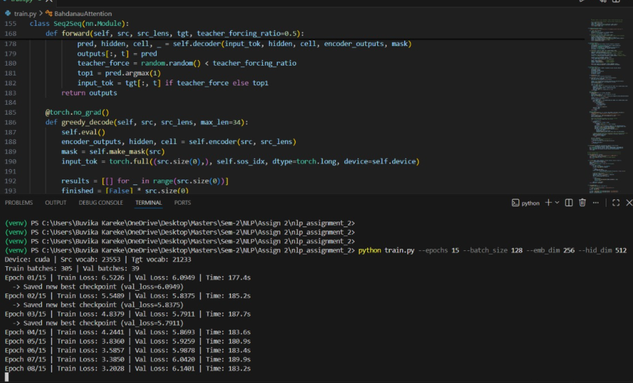
Figure 1. Training console evidence showing epoch-wise loss and checkpoint selection.
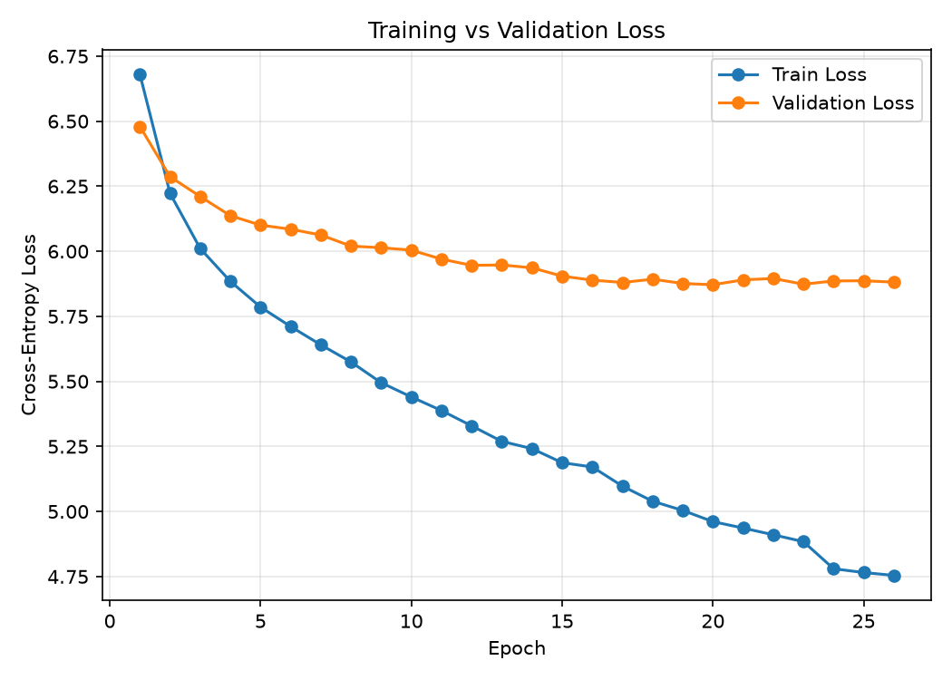
Figure 2. Training and validation loss curve from the submitted checkpoint.

Model training and inference execution in the BITS Virtual Lab : The screenshots show the successful execution of the NMT model in the BITS Virtual Lab, including model training, checkpoint saving, and sample English-to-Hindi translations.
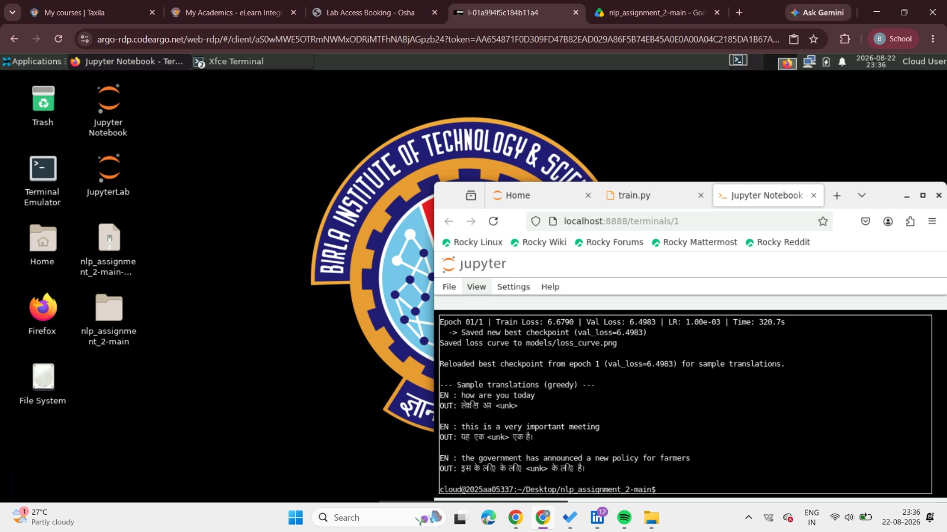

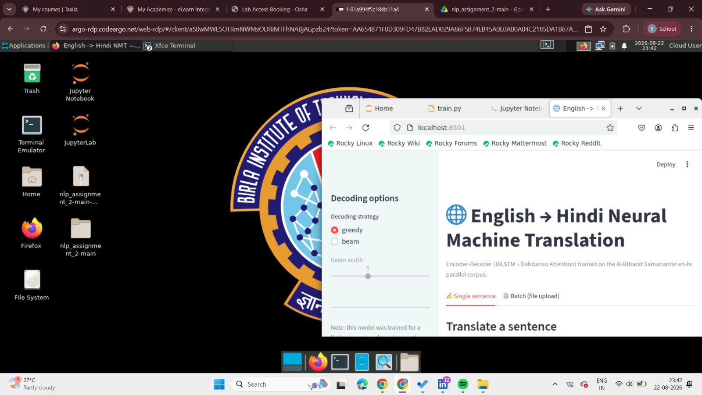

6. Working Application Evidence

6.1 Input screen and sample submitted
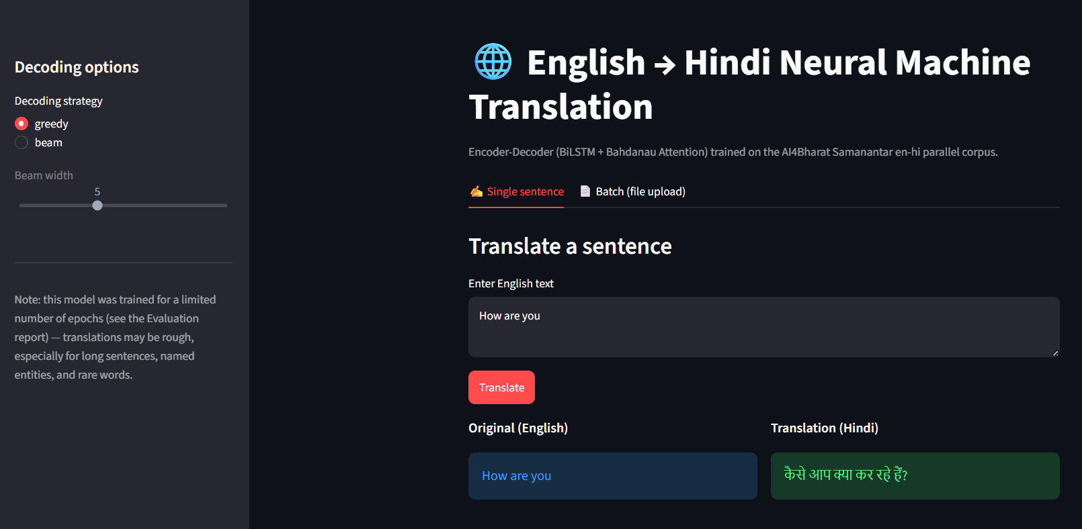
Figure 3. Single-sentence input screen with the sample how are you, greedy decoding selected, and the translation result visible.
The screen demonstrates the main interaction: the user enters English text in the text area, selects a decoding strategy in the sidebar and submits the request using the Translate button. The original English sentence and generated Hindi text are rendered in separate result panels.

6.2 Batch sample submission and generated output
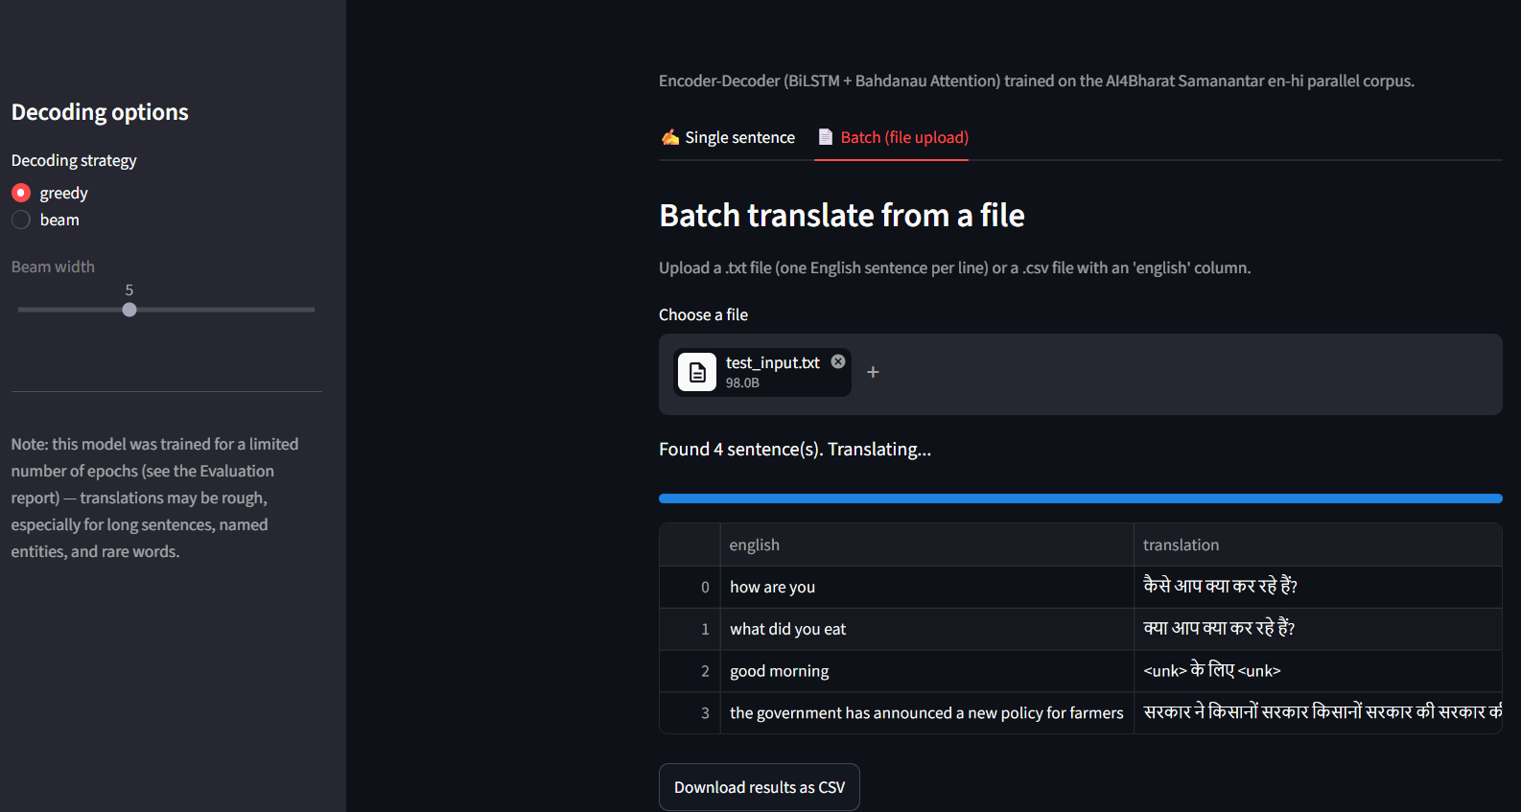
Figure 4. Batch workflow showing test_input.txt uploaded and a generated English-to-Hindi result table.
The batch path reads four non-empty lines from the uploaded text file, translates each line and presents the results in a table. The same table can be downloaded as a UTF-8 CSV file for downstream use.

6.3 Long sentence sample
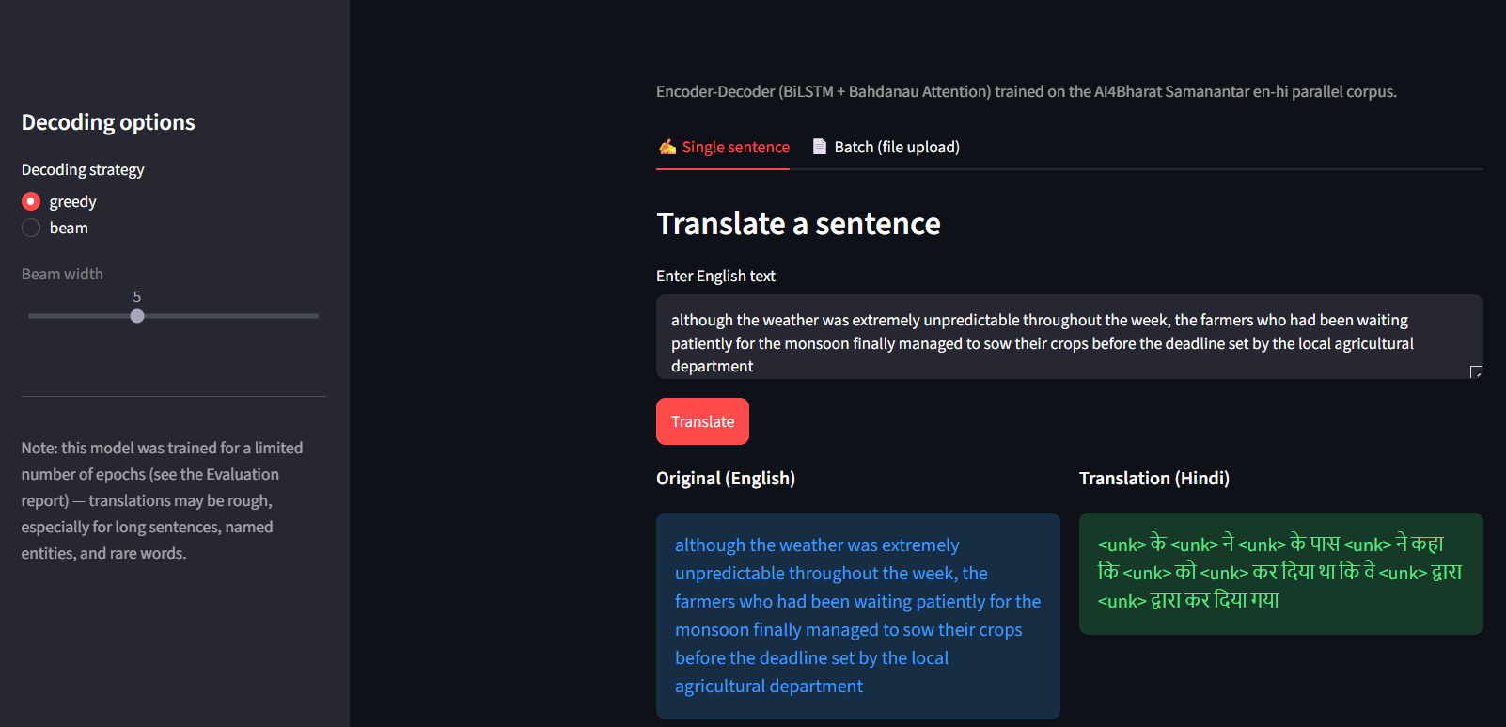

Inference Output
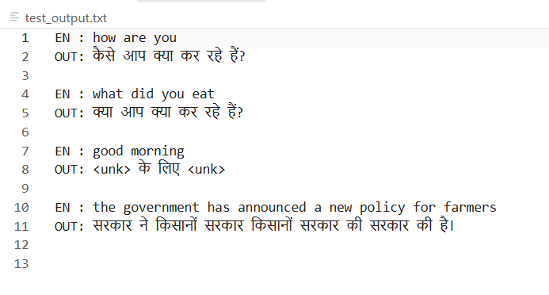
Figure 5. Inference output showing the submitted English examples and generated Hindi translations.

7. Observations and Limitations

Observations
1. The full workflow is operational: data artifacts and the trained checkpoint are available, the model loads in the application, and both single and batch interfaces are implemented.
2. The loss curve shows a strong early reduction in training loss, while validation loss improves more slowly and reaches its best value near epoch 20. Later epochs produce no meaningful validation improvement, which justifies early stopping.
3. Short and medium inputs have similar chrF performance, while long inputs are slightly weaker. This is consistent with the sequential model needing to preserve more context over longer and more complex sentences.
4. The no-repeat constraints are effective against decoding loops, but they cannot solve vocabulary coverage. Unknown-token output remains the primary quality limitation.

Limitations
The model was trained on approximately 36,000 training pairs after cleaning, with a minimum vocabulary frequency of four. Rare words and named entities can therefore map to unknown tokens or be mistranslated. The submitted checkpoint is a compact assignment-scale model rather than a production translation system. The application also relies on the included local artifacts; regenerating the dataset requires internet access to Hugging Face.

8. Conclusion
An end-to-end English-to-Hindi NMT system was implemented, evaluated and integrated into a usable Streamlit application. The repository now clearly separates preparation, training, evaluation, inference, application code and generated artifacts. The submitted model produces valid Hindi output for some common inputs and supports useful operational workflows such as beam decoding and batch CSV export.
The measured scores and failure analysis show that the project meets the implementation objective while also making its quality boundaries explicit. The strongest next step is subword-based modeling with broader data, which should directly address the observed 88.2 percent unknown-token rate and improve named-entity and long-sentence translation.

9. References
[1] AI4Bharat, Samanantar: English-Hindi parallel corpus, Hugging Face Datasets, https://huggingface.co/datasets/ai4bharat/samanantar
[2] Bahdanau, D., Cho, K. and Bengio, Y., Neural Machine Translation by Jointly Learning to Align and Translate, ICLR, 2015.
[3] PyTorch Documentation, Sequence Models and Recurrent Neural Networks, https://pytorch.org/docs/
[4] Streamlit Documentation, Build and deploy data apps, https://docs.streamlit.io/
[5] Project README and implementation files: run_pipeline.py, train.py, evaluate.py, infer.py and app.py.

Appendix: Final Application Capture
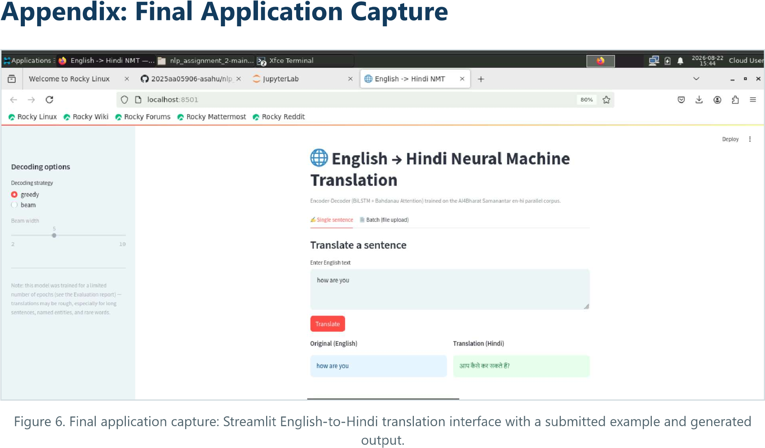
Figure 6. Final application capture: Streamlit English-to-Hindi translation interface with a submitted example and generated output

